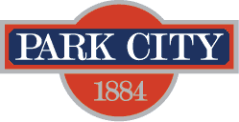

AGENDA
Park City Municipal Forestry Advisory Board
Thursday, July 6, 2023
10 am
Marsac East Conference Room

Board Member Attendance
Present:
Excused:
Absent:

Purpose & Product: To study, investigate, counsel, formulate, develop and/or update, and administer a Community Forestry Plan ("Forestry Plan") for the care, preservation, pruning, planting, replanting, removal or disposition of trees and shrubs in parks, along streets, and in other public places.

Working & Input

- 161 Park Ave Tree Removal Request
- 4867 Legacy Way Landscaping
- 7955 Red Tail Ct Landscaping
- 395 Deer Valley Dr Landscaping
- 2545 Lucky John Dr Landscaping
- 3506 Oak Wood Dr Lanscaping/Construction
- Community Wildfire Risk Assessment Update
- Forestry Plan RFP Discussion
- Board Member Updates/Roundtable

Next Meeting: Thursday, August 3, 1000-1100, Marsac East Conference Room

