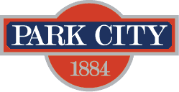

AGENDA
Park City Municipal Forestry Advisory Board
Thursday, March 14, 2024
10 am
Marsac East Conference Room

Board Member Attendance
Present:
Excused:
Absent:

Purpose & Product: To study, investigate, counsel, formulate, develop and/or update, and administer a Community Forestry Plan ("Forestry Plan") for the care, preservation, pruning, planting, replanting, removal or disposition of trees and shrubs in parks, along streets, and in other public places.

Working & Input

New Business:
7871 Red Tail Ct
City property defensible space assessments
Ongoing:
- Forestry Plan RFP Discussion and Timeline
  - Municipal Code Update
- Board Member Updates/Roundtable

Next Meeting: Thursday, March 7, 1000-1100, Marsac East Conference Room

