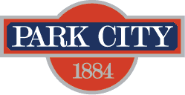

AGENDA
Park City Municipal Forestry Advisory Board
Friday, March 10, 2023
10 am
Marsac East Conference Room

Board Member Attendance
Present:
Excused:
Absent:

Purpose & Product: To study, investigate, counsel, formulate, develop and/or update, and administer a Community Forestry Plan ("Forestry Plan") for the care, preservation, pruning, planting, replanting, removal or disposition of trees and shrubs in parks, along streets, and in other public places.

Working & Input

- 1304 Park Avenue Arborist Report
- Community Wildfire Risk Assessment Update
- 2023 Defensible Space Projects
- Pile Burning & Smoke Management Discussion
- Legislative Update – HB261
- Forestry Plan Timeline
- Board Meeting Schedule

Next Meeting: Friday, April 7, 2023, 1000-1100, Marsac East Conference Room

