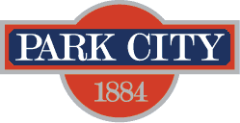

AGENDA
Park City Municipal Forestry Advisory Board
Thursday, June 8, 2023
10 am
Marsac East Conference Room

Board Member Attendance
Present:
Excused:
Absent:

Purpose & Product: To study, investigate, counsel, formulate, develop and/or update, and administer a Community Forestry Plan ("Forestry Plan") for the care, preservation, pruning, planting, replanting, removal or disposition of trees and shrubs in parks, along streets, and in other public places.

Working & Input

- Silver Creek Tree Removal
- Community Wildfire Risk Assessment Update
- Board Member Updates/Roundtable

Next Meeting: Thursday, July 6 (tentative), 1000-1100, Marsac East Conference Room

