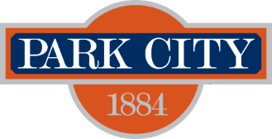
Park City Municipal Corporation – Water Resources
Low Water Landscape Program
Information and Application
Valid for projects completed April 4, 2023 – December 31, 2023
Background information:
Landscape irrigation accounts for the largest use of water in Park City during summer months. By replacing a lawn with low-water use, native, and drought tolerant plants, our summer water demand can be significantly reduced. Water efficient landscapes can be full of color and variety, are better for local wildlife and pollinators and help absorb storm water runoff during the seasons.
Available rebate:
Eligible properties may earn $2.00 per square foot of grass converted to low water (ideally) native plants.
Process (for more details www.parkcity.org):
1. Before removing your grass, please contact the Water Conservation Program at 435-615-5312 to schedule a preliminary site inspection by our staff. This preliminary inspection is necessary to confirm the square footage of eligible grass on your property.
2. Provide the Water Conservation Program with a site plan (to-scale). This plan should include which plants you intend to utilize, and how much water they require during the establishment and postestablishment phases. Fifty percent of the converted area needs to be converted to low water use and/or native plants. Only twenty percent of ground cover may be rock. Mulch is recommended, especially around new plantings. More rules and details on the website above.
3. Remove your grass and replace it with the low water use plants you have selected.
4. Contact Water Conservation for final inspection of your site, along with copies of your receipts for plants and labor (if included).
Name: Email:
Account Number:
Rebate Address:
Signature: Date:
www.parkcity.org

