Exhibit D – 2018 Parking Map

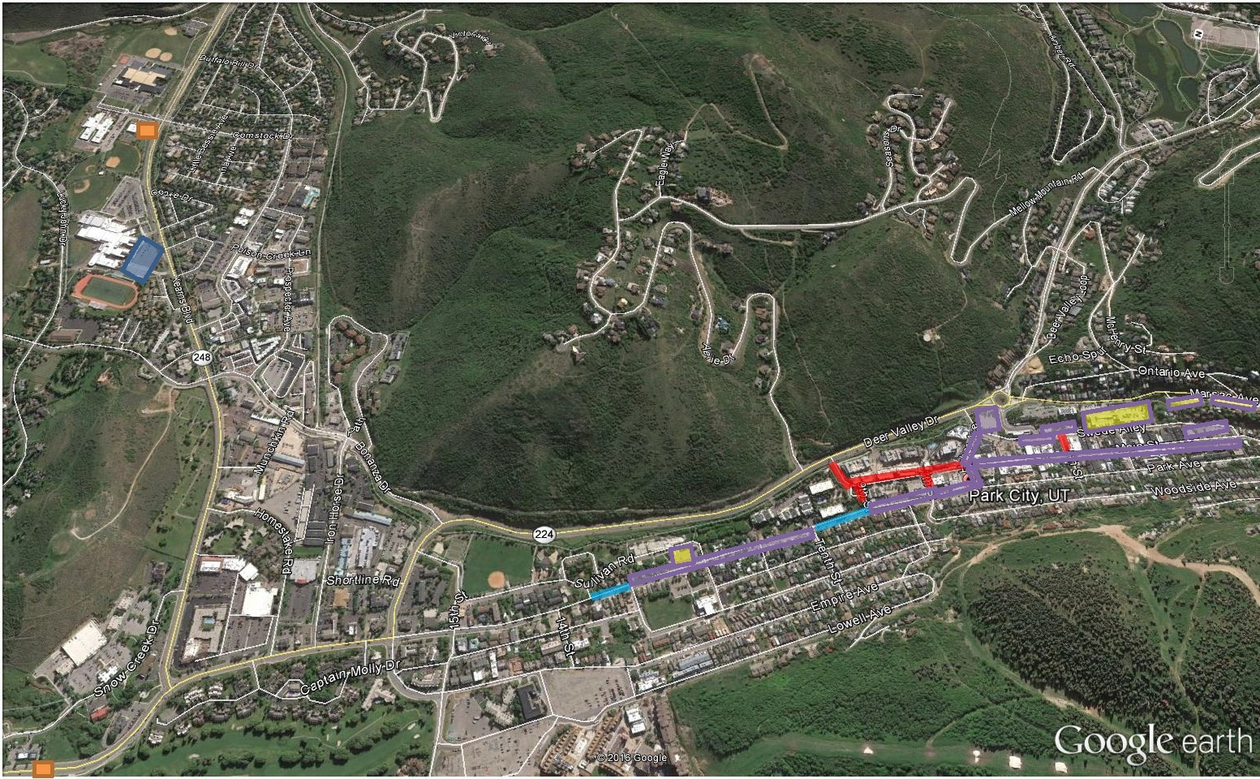

Variable Message Boards (VMS)
Supplemental Market Parking at High School
Non-exclusive PSSM vendor parking, shared general parking
No Oversized Vehicles can be parked in China Bridge

Residential Parking Zones on Park Avenue
Road Closures (Market Footprint)
General Parking

