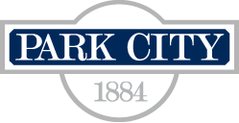
PARK CITY MUNICIPAL CORPORATION
SPECIAL MEETING FOR PLANNING COMMISSION
CITY HALL, COUNCIL CHAMBERS
August 6, 2014
LEGAL NOTICE

REGULAR SESSION – 5:30 PM – Items listed below may include discussion, public hearing, and action

Bonanza Park and Form Based Code – Review of draft regulating plan and character zones.
Discussion, public hearing and further discussion at a later date.

*Please Note* A work session may be held prior to the regular session.
Notice Published: July 19, 2014
Notice Posted: July 17, 2014
Times shown are subject to change. The public is welcome to attend both the work session and regular meeting. In order for written correspondence to be included with the Planning Commission report, please submit it to the Planning Department prior to 5:00 PM on the Thursday before the scheduled meeting. The Planning Commission meets regularly every second and fourth Wednesday of the month at 5:30 PM for action items. Times may be subject to change.

